IMA/HSG/NMC December 30, 2017

To,

Sub.: Request to oppose the oppressive clauses of the National Medical Commission (NMC) Bill in the Parliament
Respected Member of Parliament,
Greetings from Indian Medical Association (IMA)!
Indian Medical Association is the largest Association of modern medicine doctors with a strength of 3 lac doctors in 1750 branches.
National Medical Commission (NMC) Bill has been tabled in the Lok Sabha.
IMA opposes NMC in its present form. We, the representatives of all the modern medicine doctors of India, appeal to you to consider the following points and raise them in the Parliament.
Private Medical Colleges :
1. NMC is a pro private management bill paving the way for widespread corruption. It removes all the regulations before starting a medical college. No one needs any permission.
2. Any private medical college can raise its UG/PG seats by itself.
3. Only upto 40% of seats in a private medical college can be regulated by the Government. For 60% or more seats the private colleges will fix the rates.
4. Huge loopholes in financial penalties ranging from 5 crores to 100 crores opening the flood gates of corruption.
5. As a result medical education in the country will become expensive placing the lower socio economic groups in great disadvantage.
Privileges of the states
1. Only 5 states will be represented in NMC at any point of time. The other 24 will be unrepresented.
2. The state medical councils which are sovereign bodies through enactment of state legislatures will come directly under NMC.

- 2 -

3. The universities do not have a representation in NMC. One per state will be represented in an advisory body called Medical Advisory Council.

Crosspathy
1. Unscientific mixing of systems will endanger the lives of patients.
2. Provides separate registration and bridge courses for AYUSH practitioners to enable them to practise modern medicine.
3. Joint medical council meetings will ensure mixing the curriculum of all the systems.
Foreign Medical graduates
1. Any foreign doctor can practise in India without any restriction.
2. The screening test for Foreign Medical Graduates has been abolished.
Indian Medical Graduates.
All Indian Medical graduates should undergo a licentiate exam to be allowed to practice.
Undemocratic non representative.
1. Out of 25 members only 5 will be elected.
2. A group of non medical members are included
3. All the non elected members will be either Government officials or nominated by the Government.
- This bill is anti-people since it is pro-rich and pro-private managements.
- The cost of medical education and healthcare will raise astronomically.
- It is anti-patient since it promotes unscientific mixing of systems.
- It closes the gate for Indian Medical graduates while opens the gate for foreign doctors and foreign educated medical graduates.
- A medical Bill without the concurrence of the medical profession will be a disaster.
We appeal to you to raise your voice against the oppressive clauses of this bill.
Thanking you
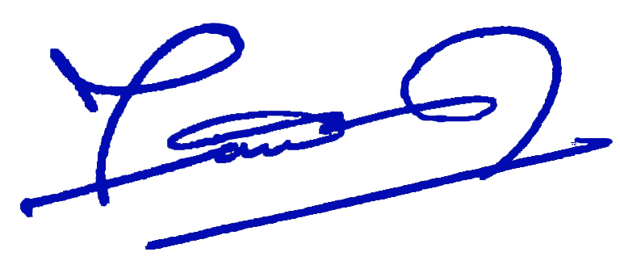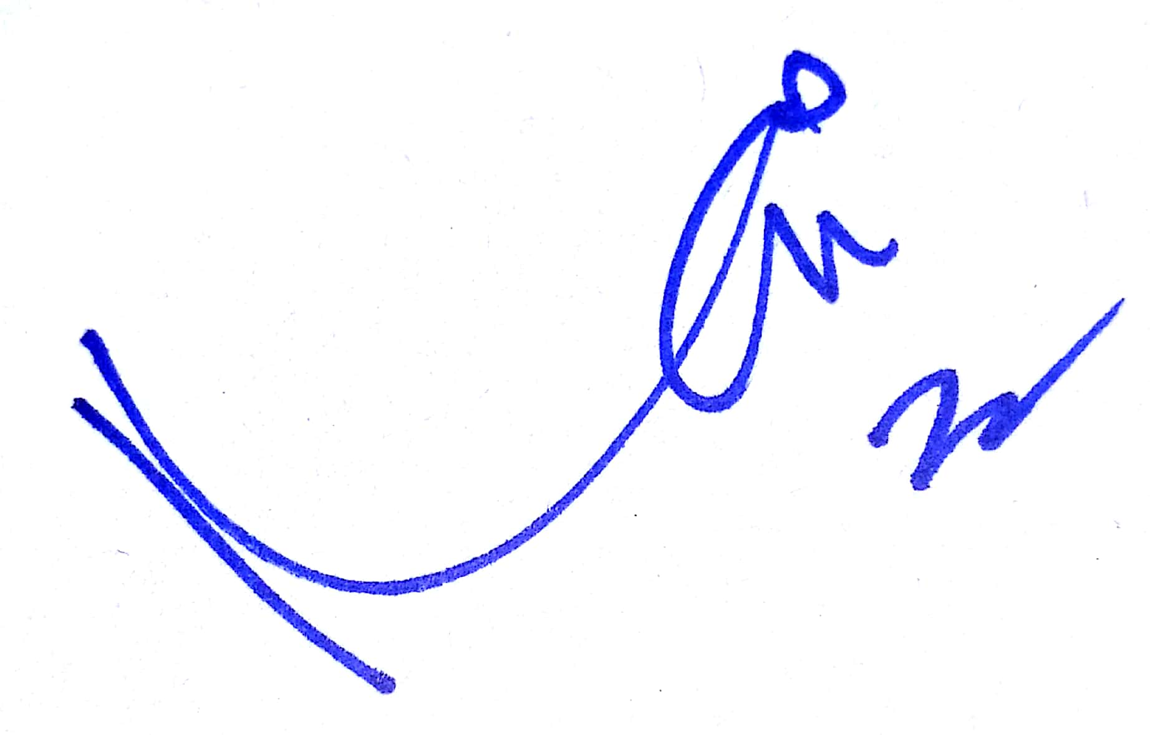Yours sincerely

Dr Ravi Wankhedkar Dr R N Tandon
National President Honorary Secretary General

